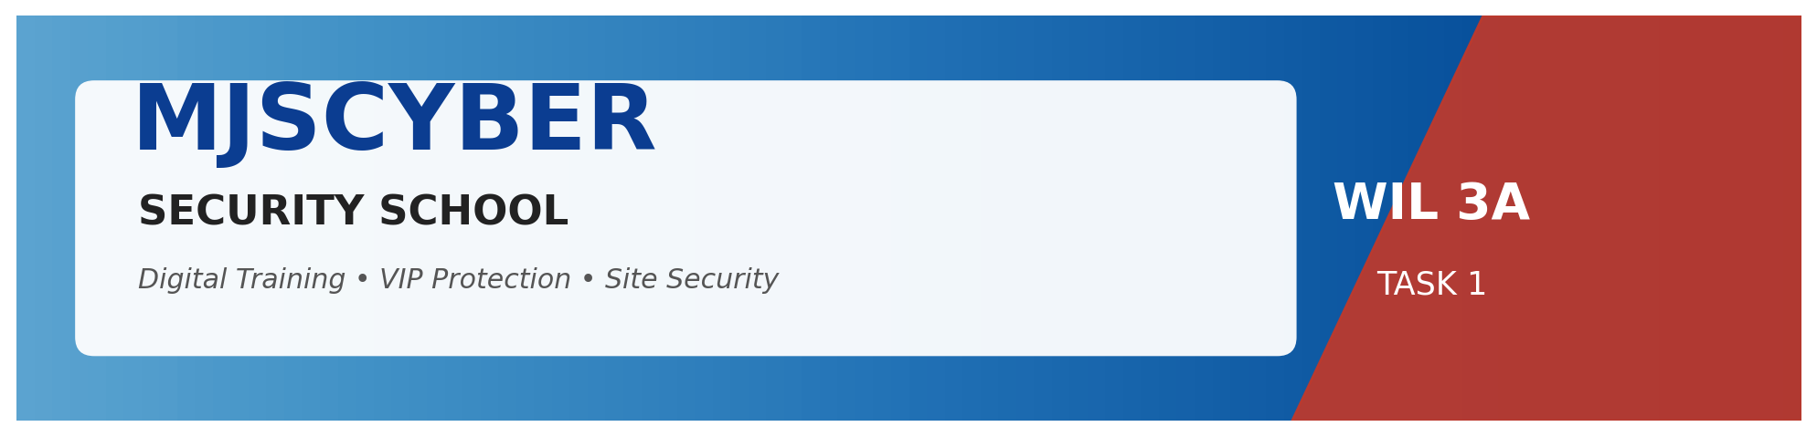

WIL – WORK INTEGRATED LEARNING 3A | Module XISD5319


A modern, digitally-enabled Security School for the Limpopo region

TASK 1 – PROJECT PLAN
MJSCYBER Security School – Web Application & Database

Prepared For | MJSCYBER PTY LTD (Reg: 2022/201980/07)
Prepared By | Jones Sepuru & Khumela Sendelani
Client Location | Bochum, Limpopo, South Africa
Submission Date | 22 April 2026
Document Version | 1.0 – Final

Annexure D – Assessment Rubric Cover Sheet
Include this rubric with the submission as part of the ONE document.
MODULE NAME | MODULE CODE
WIL – Work Integrated Learning 3A | XISD5319

Group Members
Student Name | Jones Sepuru
Student Number | [Insert Student Number]
Student Name | Khumela Sendelani
Student Number | [Insert Student Number]

Task 1 Marking Rubric – Self Assessment Mapping
Each criterion below is addressed in the corresponding numbered section of this document.
Marking Criteria | Marks | Addressed In
Introduction | 5 | Section 1
Milestones & Deliverables | 5 | Section 2
Work Breakdown Structure | 10 | Section 3
Gantt Chart & Interpretation | 10 | Section 4
Risk Management | 20 | Section 5
Technical Feasibility | 15 | Section 6
Economic Feasibility | 15 | Section 7
Team Members | 5 | Section 8
Document Format & Layout | 15 | Throughout Document
TOTAL | 100 | —

Executive Summary
MJSCYBER PTY LTD (Reg 2022/201980/07), a registered private security training provider based in Bochum, Limpopo, is transitioning from paper-based operations to a fully digital training and service-delivery platform. This Project Plan defines the scope, schedule, cost and risk profile for the delivery of the MJSCYBER Security School Web Application & Database over a 14-week window (04 May – 05 August 2026).
At a Glance
Dimension | Summary
Client | MJSCYBER PTY LTD — Bochum, Limpopo
Project | 3-tier web app: Student Enrolment, Grading, Digital Certification, VIP & Site-Security Scheduling, Admin Dashboard
Team | Jones Sepuru (PM & Lead Backend) • Khumela Sendelani (Lead Frontend & Docs)
Duration | 70 working days (~14 weeks) — 5 phases, 20 tasks, 5 milestones
Total Budget | R 84 500 (incl. 9 % contingency)
ROI Payback | ≈ 8.9 months
Key Risks | 8 risks registered; top 3: load-shedding, scope creep, data-security breach
Go-Live | 05 August 2026
Table 0.1 – Project at a glance
Business Value

Figure 0.1 – Tamper-proof digital certificates with QR verification
70 % reduction in administrative time per student intake.
Tamper-proof digital certificates with a public QR-verification page — protects the MJSCYBER brand.
Real-time VIP and construction-site guard scheduling replaces spreadsheets and phone calls.
POPIA-aligned, auditable digital records satisfy PSiRA compliance.
Cloud-ready architecture enables expansion to additional campuses without a rebuild.
Recommendation
This plan is technically, economically and operationally feasible within the proposed timeline and budget. Approval to proceed is therefore recommended, with kick-off on 04 May 2026.

Table of Contents
0. | Executive Summary | 3
1. | Introduction | 5
2. | Milestones and Deliverables | 6
3. | Work Breakdown Structure (WBS) | 7
4. | Project Schedule – Gantt Chart & Interpretation | 9
5. | Risk Management | 10
6. | Technical Feasibility | 12
7. | Economic Feasibility | 13
8. | Team Members | 14
9. | Conclusion | 15
10. | Appendices | 16

1. Introduction

Figure 1.1 – Private security and training is a high-growth sector in South Africa
This project plan presents the complete roadmap for the development and deployment of the MJSCYBER Security School Web Application and Database. MJSCYBER PTY LTD (Registration 2022/201980/07), headquartered in Bochum, Limpopo, is a registered private security training provider specialising in guard training (Grades E–A), armed response, VIP protection and construction-site security. The organisation currently operates using paper-based registration, manual grading and physical certificate issuance, which introduces fraud risk, data loss and scaling limitations.
1.1 Customer Needs
Digitise the student registration, document-upload and payment workflow to eliminate paperwork.
Provide a tamper-proof certificate issuance and public verification mechanism to protect the MJSCYBER brand.
Enable real-time scheduling of VIP protection details and construction-site guard shifts.
Deliver an Admin dashboard that exposes enrolment, revenue and compliance reports at a glance.
Operate reliably on the limited bandwidth available in the Bochum / Limpopo region.
1.2 Project Goals
Deliver a fully functional 3-tier web application (Frontend / Backend / Database) within 14 weeks.
Achieve ≥ 95 % Automated Test coverage on the enrolment, grading and certification modules.
Reduce manual administrative time per student intake by at least 70 %.
Issue verifiable digital certificates with a unique serial number and QR-based public lookup.
Train MJSCYBER staff to independently manage the system post-handover.
1.3 Budget Summary
The total estimated project budget is ZAR 84 500, covering development labour, hosting, software licences, hardware allowances and contingency. A full cost breakdown is presented in Section 7 – Economic Feasibility.
1.4 Key Risks (Summary)
Load-shedding and rural connectivity in Bochum — mitigated by offline-capable design and cloud hosting.
Scope creep from stakeholder change requests — mitigated by a signed scope document and change-control log.
Data-security breach of student ID documents — mitigated by encryption at rest and role-based access control.
Key-person dependency (2-member team) — mitigated by cross-training and shared Git repository.
A full risk register with probability, impact and mitigation is provided in Section 5.
1.5 Expected Benefits
Operational efficiency: instant enrolment and certificate generation replace a 3-day manual process.
Revenue growth: online visibility and a public certificate-verification page increase corporate-client trust.
Compliance: auditable digital records meet PSiRA (Private Security Industry Regulatory Authority) requirements.
Scalability: cloud-ready architecture allows MJSCYBER to expand to additional campuses without rebuild.
Return on Investment: full ROI is projected within 12 months based on reduced admin costs and increased intake capacity.

2. Milestones and Deliverables
Five major milestones have been defined to structure delivery and provide clear go/no-go decision points. Each milestone is linked to a tangible deliverable and mapped directly to customer needs stated in Section 1.1.
ID | Milestone | Target Date | Deliverable | Link to Customer Need
M1 | Scope Sign-off | 15 May 2026 | Approved Project Charter, Signed Scope Statement | Addresses customer need for clear deliverables
M2 | Design Freeze | 25 May 2026 | ERD, Wireframes, Technical Architecture Document | Ensures solution matches MJSCYBER workflows
M3 | Development Complete | 10 July 2026 | Working Web App (all modules), Source Code on Git | Delivers the full digital ecosystem
M4 | UAT Pass | 24 July 2026 | Signed UAT Report, Bug-fix log | Confirms fitness-for-purpose with client
M5 | Go-Live & Handover | 05 Aug 2026 | Deployed system, Training Manual, Admin handover | Achieves digital transformation goal
Table 2.1 – Project Milestones and Deliverables
2.1 Deliverable Acceptance Criteria
Each deliverable must be reviewed and signed off by the MJSCYBER director (Mr. M. J. Sepuru) before the next phase starts.
Development deliverables must pass automated unit tests and a peer code review on GitHub.
Documentation deliverables must follow the approved MJSCYBER document template (corporate seal, footer, numbered sections).

3. Work Breakdown Structure (WBS)

Figure 3.1 – Iterative, phase-based development approach
The Work Breakdown Structure decomposes the project into five phases and twenty discrete tasks. Every task lists its description, duration, predecessor, responsible team member and required resources — satisfying the top-band rubric requirement.
ID | Task | Description | Duration | Pred. | Responsible | Resources
1.1 | Kick-off & Stakeholder Meeting | Align on vision, goals, constraints with MJSCYBER director. | 3 d | — | Both | Meeting room, MS Teams
1.2 | Requirements Gathering | Interview instructors, students, admin; document needs. | 5 d | 1.1 | Khumela | Notepad, recorder, questionnaire
1.3 | Scope Sign-off & Charter | Draft and obtain signature on project charter & scope. | 2 d | 1.2 | Jones | MS Word, e-signature
2.1 | Use-Case & Process Mapping | Model each business workflow using UML use-case diagrams. | 4 d | 1.3 | Khumela | draw.io / Lucidchart
2.2 | Database Schema Design (ERD) | Design normalised MySQL schema, primary/foreign keys. | 5 d | 1.3 | Jones | MySQL Workbench
2.3 | UI / UX Wireframes | Produce low- and high-fidelity wireframes & style guide. | 5 d | 2.1 | Khumela | Figma
2.4 | Technical Architecture Doc | Document 3-tier architecture, tech stack, security model. | 3 d | 2.2 | Jones | MS Word
3.1 | Environment Setup & Repo | Configure local XAMPP, Git repo, issue tracker. | 2 d | 2.4 | Jones | XAMPP, GitHub, VS Code
3.2 | Authentication Module | Login, password hashing, session, role-based access. | 6 d | 3.1 | Jones | PHP, MySQL, bcrypt
3.3 | Enrolment & Document Upload | Student profile, ID/cert upload, payment confirmation. | 8 d | 3.2 | Jones | PHP, MySQL, filesystem
3.4 | Grading & Qualification Engine | Capture marks, auto-audit pass criteria, fee check. | 7 d | 3.3 | Jones | PHP, MySQL
3.5 | Certificate Issue & Verify Page | Generate PDF cert with serial + QR; public verify URL. | 6 d | 3.4 | Khumela | TCPDF library, QR library
3.6 | VIP & Site-Security Scheduling | Client requests, guard availability, GPS-tagged shifts. | 7 d | 3.3 | Khumela | PHP, MySQL, JS calendar
3.7 | Admin Dashboard & Reporting | KPIs, enrolment, revenue, compliance, PDF export. | 5 d | 3.4 | Khumela | Chart.js, PHP
4.1 | Unit & Integration Testing | Write & execute PHPUnit tests on all modules. | 5 d | 3.7 | Jones | PHPUnit, Postman
4.2 | User Acceptance Testing | Guided UAT with MJSCYBER staff; log defects. | 4 d | 4.1 | Khumela | Test scripts, laptop
4.3 | Bug Fixes & Performance Tuning | Resolve UAT defects; optimise queries & assets. | 4 d | 4.2 | Both | VS Code, MySQL profiler
5.1 | Deployment to Hosting | Deploy to cPanel host (Afrihost), configure domain, SSL. | 2 d | 4.3 | Jones | cPanel, Let's Encrypt
5.2 | Staff Training & Handover Docs | Train admin, create user and admin manuals. | 3 d | 5.1 | Khumela | MS Word, Projector
5.3 | Go-Live & Post-Launch Support | Monitor live traffic, resolve incidents for 1 week. | 5 d | 5.2 | Both | Hosting panel, email
Table 3.1 – Work Breakdown Structure (full)
3.1 WBS Summary by Phase
Phase | Duration | Tasks
Phase 1 – Initiation | 10 days | 1.1 – 1.3
Phase 2 – Analysis & Design | 10 days | 2.1 – 2.4
Phase 3 – Development | 30 days | 3.1 – 3.7
Phase 4 – Testing | 10 days | 4.1 – 4.3
Phase 5 – Deployment | 10 days | 5.1 – 5.3
Total Duration | 70 working days (~14 weeks) | —
Table 3.2 – WBS summary by phase

4. Project Schedule – Gantt Chart & Interpretation
The Gantt chart below translates the WBS into a visual timeline. It shows each task's start and end dates, its phase (colour-coded), the responsible team member, and the five project milestones (dotted red lines).
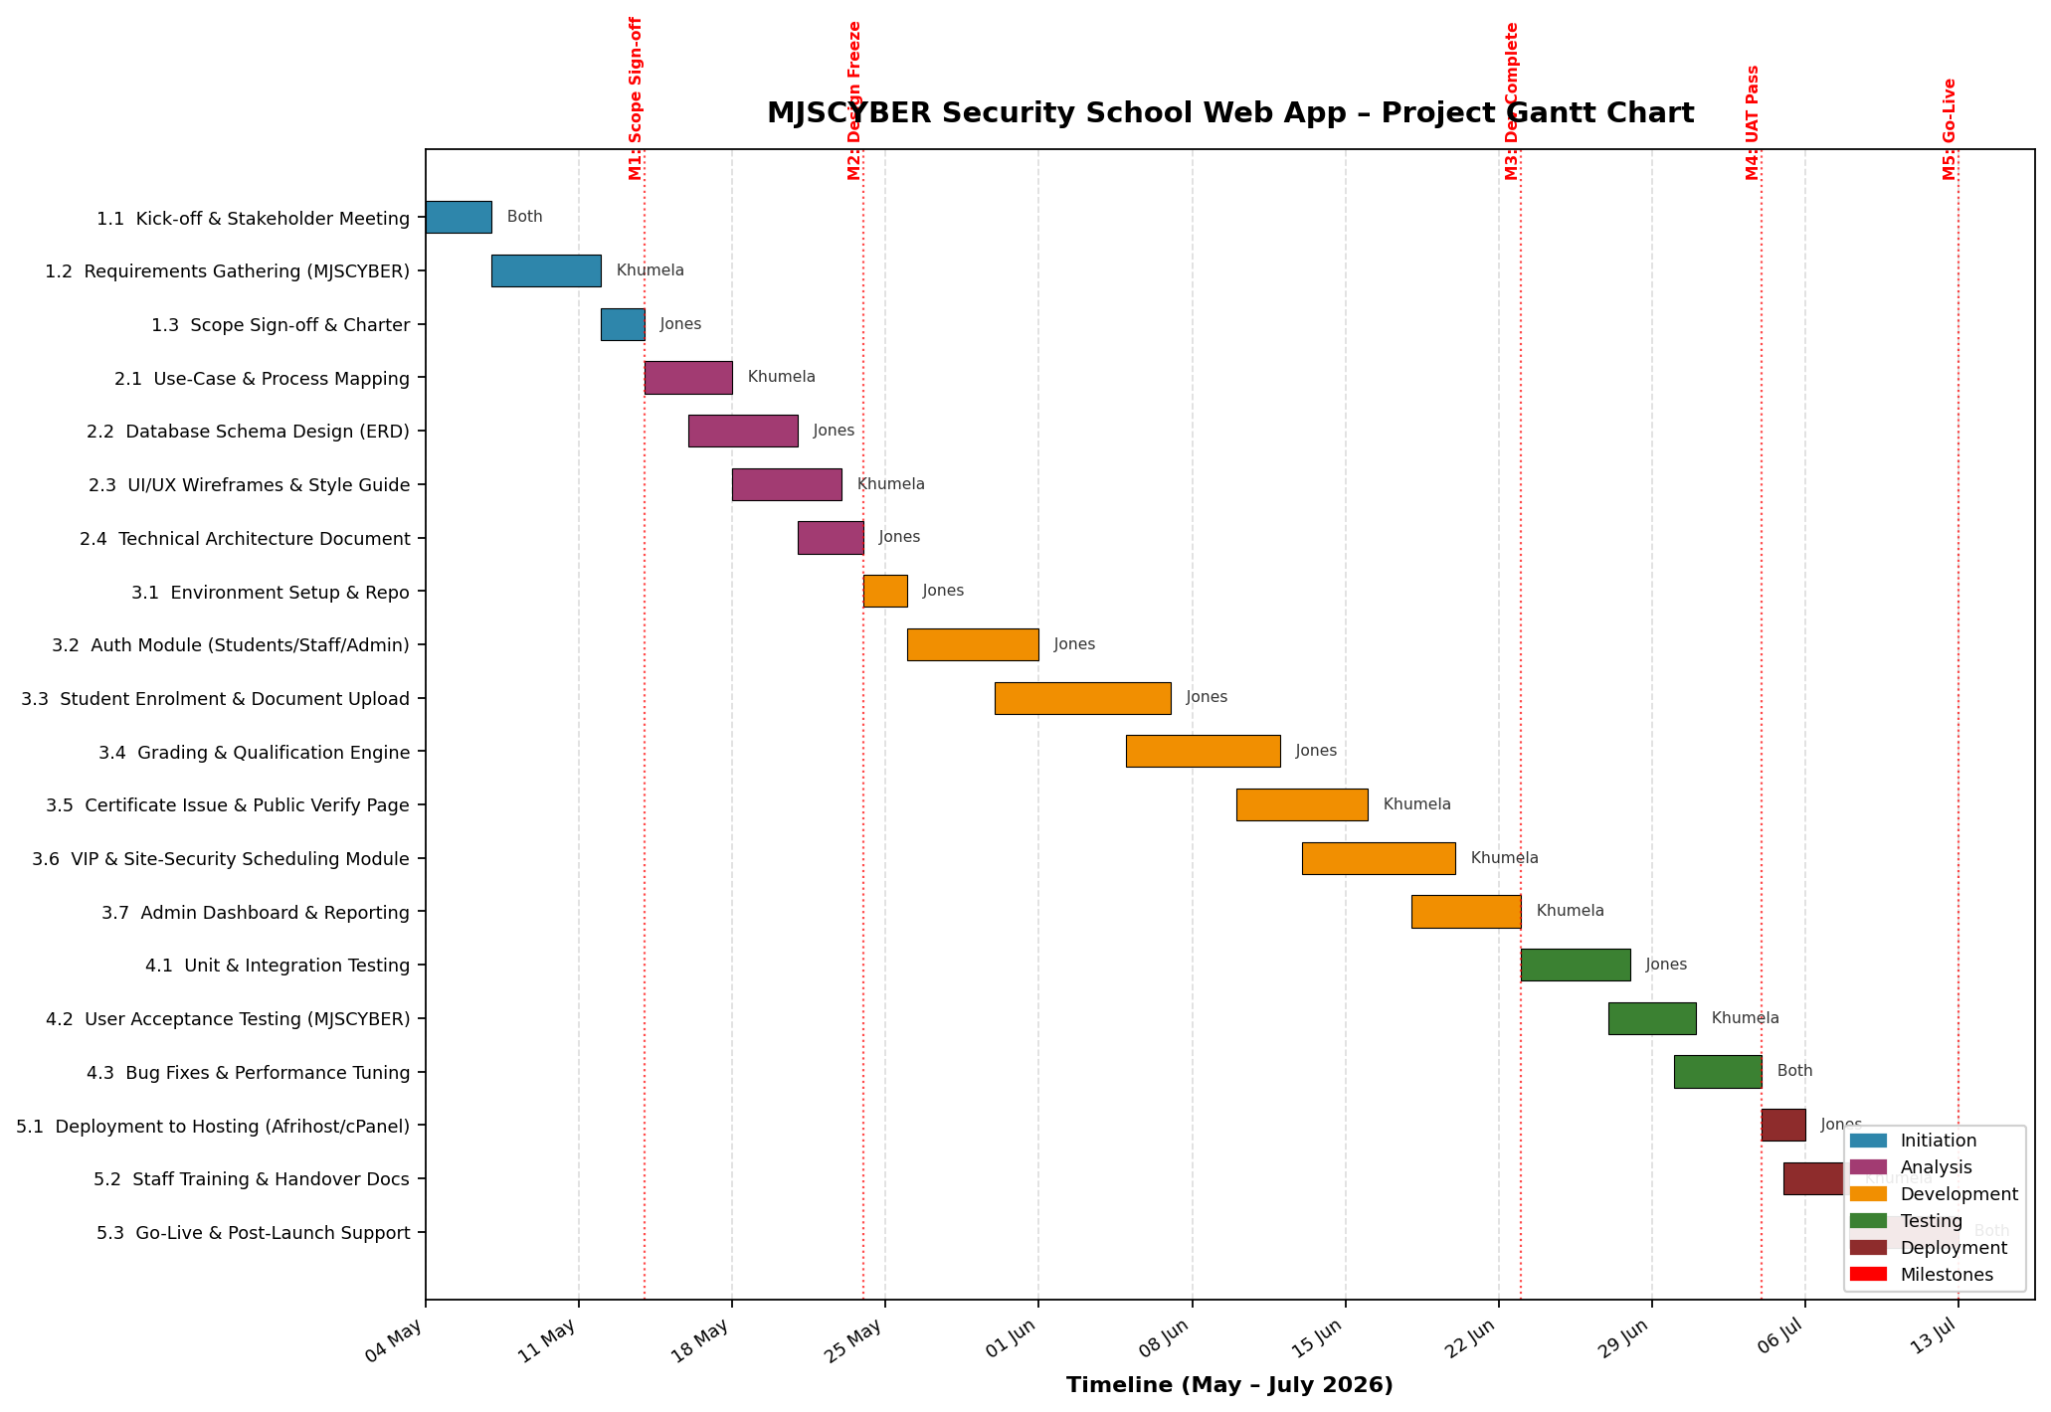
Figure 4.1 – MJSCYBER Project Gantt Chart (May – August 2026)
4.1 Interpretation of the Gantt Chart
Critical path: Tasks 1.1 → 1.3 → 2.2 → 3.1 → 3.2 → 3.3 → 3.4 → 4.1 → 4.3 → 5.1 → 5.3 drive total project duration; any delay on these tasks delays go-live.
Parallelism: UI wireframing (2.3) runs in parallel with database design (2.2), and the Certificate/Verify module (3.5) runs alongside the Scheduling module (3.6), compressing the schedule by ~12 working days.
Load balancing: Jones carries most backend-heavy tasks (auth, enrolment, grading) while Khumela leads UI, certification UI and scheduling UI — aligning workload with individual skills.
Buffer: Task 4.3 (Bug Fixes) provides a 4-day buffer before deployment, absorbing minor schedule slippage from UAT.
Milestones M1–M5 serve as formal sign-off gates; the project cannot advance past a milestone without client approval, enforcing discipline.

5. Risk Management
A comprehensive risk register has been developed. Each risk is rated for probability (1–5) and impact (1–5); the product is the Risk Score, which informs mitigation priority. Proactive mitigation and a contingency plan are defined for every risk.
ID | Risk Description | Category | P (1-5) | I (1-5) | Score | Proactive Mitigation | Contingency
R1 | Load-shedding / power outages in Bochum disrupting development and demos. | Operational | 5 | 4 | 20 | Deploy to cloud-hosted environment (Afrihost) from day 1; team to use laptops with UPS & mobile hotspot. | Switch to offline coding and sync to Git when power returns; reschedule demos.
R2 | Scope creep from stakeholder change requests after sign-off. | Managerial | 4 | 4 | 16 | Signed scope statement (M1); formal Change Request form required for every new feature. | Re-baseline schedule & budget; defer non-critical requests to Phase 2.
R3 | Security breach exposing student ID documents and personal data. | Security | 3 | 5 | 15 | Password hashing (bcrypt), HTTPS-only, prepared statements, RBAC, encrypted file storage. | Invoke incident-response plan; notify affected users & Information Regulator per POPIA.
R4 | Key-person dependency — illness of a 2-member team could stall delivery. | Human Resources | 3 | 4 | 12 | Cross-train each member on the other's module; shared Git repo; weekly pair-programming. | Engage a university peer as a short-term backup developer; extend buffer in Task 4.3.
R5 | Rural low-bandwidth users experience slow page loads. | Technical | 4 | 3 | 12 | Lightweight frontend (no heavy frameworks), image compression, server-side caching. | Enable Cloudflare CDN; provide simplified mobile view.
R6 | Hardware failure (laptop crash) with loss of local code. | Technical | 2 | 5 | 10 | Daily Git commits to GitHub remote; cloud backup (Google Drive) of design assets. | Restore from latest commit within 2 hours; replace laptop from departmental loan pool.
R7 | Budget overrun due to unforeseen software licence or hosting fees. | Financial | 3 | 3 | 9 | 15 % contingency included in budget (Section 7); prefer open-source tools. | Re-negotiate hosting annual plan; reduce non-essential paid services.
R8 | Integration failure of the digital certificate PDF library. | Technical | 2 | 4 | 8 | Prototype TCPDF early in Task 3.5; maintain a fallback to DOMPDF. | Switch to alternative library (DOMPDF); reassign 2 buffer days from Task 4.3.
Table 5.1 – Risk Register (8 risks)
5.1 Risk Heat-Map Summary
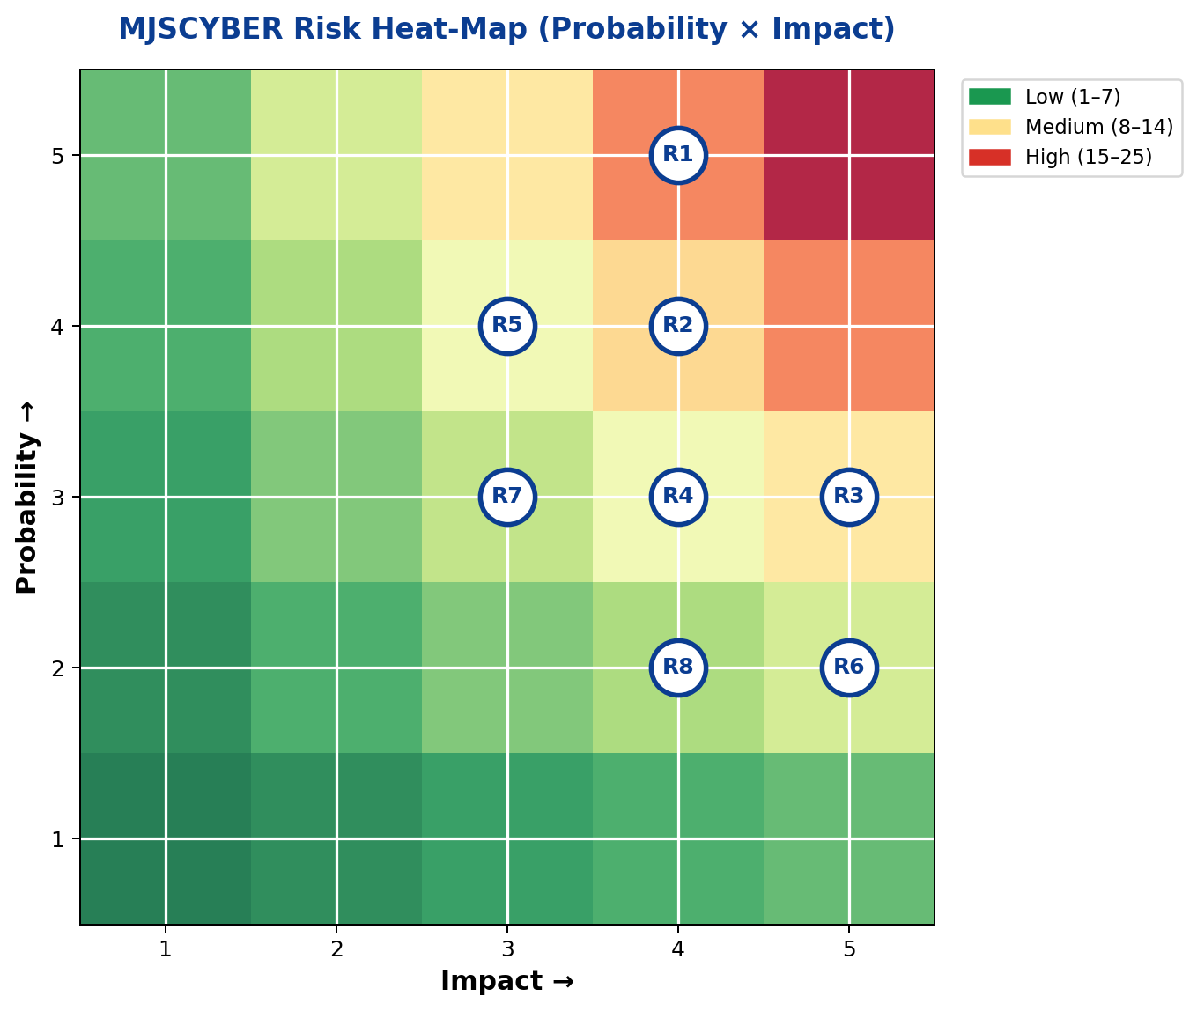
Figure 5.1 – Probability × Impact heat-map (all 8 registered risks plotted)
Score Band | Risks | Monitoring Cadence
High (15–25) | R1, R2, R3 | Weekly monitoring by Project Manager; standing item on status meeting.
Medium (8–14) | R4, R5, R6, R7, R8 | Bi-weekly review; owner assigned.
Low (1–7) | None currently | Monthly review.
Table 5.2 – Risk prioritisation heat-map
5.2 Risk Governance
The Project Manager (Jones Sepuru) owns the risk register and updates it weekly.
New risks identified during the project are added with the same P × I scoring model.
Any risk that materialises is logged as an Issue and tracked until closure.

6. Technical Feasibility

Figure 6.1 – 3-tier cloud-hosted architecture on shared cPanel infrastructure
This section confirms that every hardware and software resource needed to deliver the MJSCYBER Security School Web App is available, costed and supported. Availability risks and their mitigations are explicitly addressed.
6.1 Hardware Resources
Resource | Specification | Cost | Availability | Availability Risk / Mitigation
Developer Laptop × 2 | Intel i5 / 8 GB RAM / 256 GB SSD | Owned by team | Available | Low
External HDD 1 TB | USB 3.0 backup drive | R 850 each | Purchase in week 1 | Low
UPS (Uninterruptible PS) | 650 VA line-interactive | R 1 200 each | Purchase in week 1 | Addresses R1 (load-shedding)
Mobile 4G Router | LTE router + 50 GB data SIM | R 600 + R 299/m | Purchase in week 1 | Addresses R1
Cloud Hosting (cPanel) | Afrihost Home Executive — 10 GB + DB | R 179 / month | Subscribe in week 2 | Addresses R1, R5
Projector (for training) | Borrowed from campus lab | R 0 | Reserved for M5 | Low
Table 6.1 – Hardware feasibility matrix
6.2 Software Resources
Software | Purpose | Licence / Cost | Availability | Risk / Mitigation
XAMPP (Apache, PHP 8, MySQL) | Local dev stack | Free (Open Source) | Downloadable | None
Visual Studio Code | IDE | Free | Downloadable | None
MySQL Workbench | DB design & admin | Free | Downloadable | None
Figma (Starter) | UI/UX wireframes | Free tier | Web-based | None
draw.io / Lucidchart | UML diagrams | Free / Free tier | Web-based | None
GitHub | Version control & CI | Free for students | Cloud | None
TCPDF + QRCode library | Digital certificates | Free (LGPL) | Composer pkg | Fallback: DOMPDF (R8)
Chart.js | Admin dashboard charts | Free | CDN | None
Let's Encrypt SSL | HTTPS certificate | Free | cPanel AutoSSL | None
PHPUnit + Postman | Testing | Free | Downloadable | None
Table 6.2 – Software feasibility matrix
6.3 Technical Skills Match
Skill | Owner | Proficiency / Justification
PHP (OOP) & MySQL | Jones Sepuru | Strong – completed Web Dev III with distinction.
HTML/CSS/JS & UI/UX | Khumela Sendelani | Strong – completed Interactive Design III.
Database Design | Jones Sepuru | Strong – 2 years SQL coursework + personal projects.
Project Management | Jones Sepuru | Moderate – supported by lecturer mentorship.
Technical Writing | Khumela Sendelani | Strong – acts as documentation lead.
Table 6.3 – Team skills vs project requirements
6.4 Feasibility Conclusion
All required hardware is either owned or affordable within the budget; all required software is open-source or free-tier; and the team's skills map directly to every technical requirement. The project is therefore technically feasible.

7. Economic Feasibility
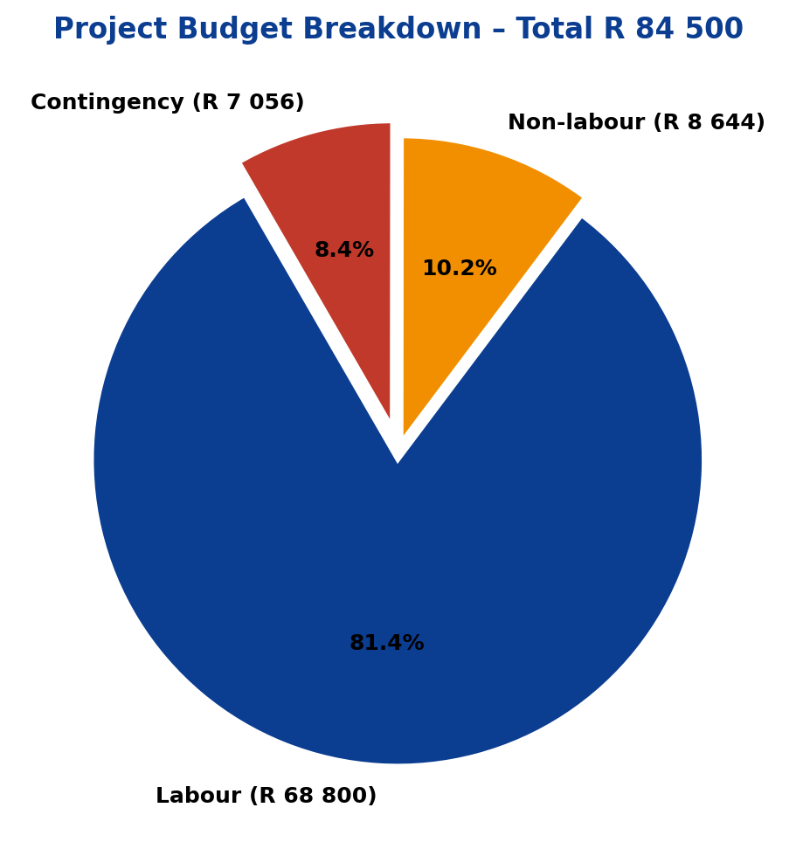
Figure 7.1 – Project budget breakdown (Total R 84 500)
The table below lists every project activity, the responsible person, the time required, the tariff (hourly rate) applied, and the computed cost. Non-labour costs (hardware, hosting, contingency) are presented separately.
Activity | Responsible | Time | Tariff (ZAR/h) | Cost (ZAR)
Kick-off & Requirements | Both | 40 h | R 150 | R 6 000
Analysis & Design | Both | 80 h | R 150 | R 12 000
Auth & Enrolment Dev | Jones | 60 h | R 170 | R 10 200
Grading & Certification Dev | Jones+Khumela | 80 h | R 170 | R 13 600
VIP/Scheduling & Dashboard Dev | Khumela | 60 h | R 170 | R 10 200
Testing (Unit, Integ, UAT) | Both | 50 h | R 150 | R 7 500
Deployment & Training | Both | 30 h | R 150 | R 4 500
Documentation & PM | Both | 40 h | R 120 | R 4 800
Table 7.1 – Activity-based labour cost
7.1 Non-Labour Costs
Item | Cost (ZAR)
External HDD 1 TB × 2 | R 1 700
UPS × 2 | R 2 400
4G Router + 3 months data | R 1 497
Hosting (Afrihost) × 3 months + domain | R 747
Printing & stationery | R 500
Travel to MJSCYBER site (Bochum) × 2 | R 1 800
Subtotal – Non-labour | R 8 644
Table 7.2 – Non-labour cost breakdown
7.2 Total Cost Calculation
Line Item | Amount (ZAR)
Total Labour (Table 7.1) | R 68 800
Total Non-Labour (Table 7.2) | R 8 644
Subtotal | R 77 444
Contingency (≈ 9 %) | R 7 056
Grand Total Project Budget | R 84 500
Table 7.3 – Total project budget
7.3 Return on Investment (ROI)
MJSCYBER currently loses an estimated ZAR 9 500 per month to manual administration, misplaced records and delayed certificate issuance. At this saving rate, the project pays for itself within approximately 9 months:
ROI Payback = R 84 500 ÷ R 9 500 ≈ 8.9 months
Additional upside (not included in the payback calculation): increased corporate-client trust from the public verification page is expected to grow intake by 15 – 20 % in Year 2. The project is therefore economically feasible.

8. Team Members
The project is delivered by a focused two-member team. Both members hold clearly defined roles and complementary skill sets.

Khumela Sendelani

Jones Sepuru

Name | Role | Responsibilities
Jones Sepuru | Project Manager & Lead Backend Developer | Overall delivery; timeline; stakeholder liaison; PHP/MySQL development of Auth, Enrolment and Grading modules; testing lead.
Khumela Sendelani | Lead Frontend Developer & Documentation Officer | UI/UX; Certificate & Verify UI; VIP/Scheduling module; Admin dashboard; user manuals and training.
Table 8.1 – Team composition and responsibilities
8.1 Team Member CVs (Concise)
Jones Sepuru — Project Manager & Lead Backend Developer
Education: BSc IT (Software Development), 3rd year — current GPA ≈ 75 %.
Key modules passed: Programming II & III (Java / C#), Web Development III (PHP), Database II (MySQL), Software Engineering III.
Projects: Student results portal (PHP/MySQL); small e-commerce site for a local trader.
Strengths: OOP design, relational-database modelling, secure coding, leadership.
Contact: jones.sepuru@mjscyber.co.za | +27 (0) 00 000 0000

Khumela Sendelani — Lead Frontend Developer & Documentation Officer
Education: BSc IT (Software Development), 3rd year — current GPA ≈ 72 %.
Key modules passed: Interactive Design III, Web Development III, Professional Communication III.
Projects: Campus-events landing page (HTML/CSS/JS); Figma redesign of a local NGO website.
Strengths: Responsive UI, Figma wireframing, technical writing, user training.
Contact: khumela.sendelani@mjscyber.co.za | +27 (0) 00 000 0000
8.2 Project Sponsor (Client)
Mr. Matjentje Jones Sepuru — Director, MJSCYBER PTY LTD — provides domain expertise, sign-off authority and access to end-users for UAT.

9. Conclusion

Figure 9.1 – Security, trust and digital transformation at MJSCYBER
This Project Plan delivers a complete, justified and costed roadmap for transforming MJSCYBER's paper-based security school into a modern digital ecosystem. Customer needs have been translated into measurable goals, a 70-day schedule, a WBS of 20 tasks, a visual Gantt timeline, an 8-risk register, and both technical and economic feasibility studies. With an approved budget of R 84 500 and an expected payback period of under 9 months, the project offers MJSCYBER clear operational, compliance and revenue benefits.
The team — Jones Sepuru and Khumela Sendelani — is confident that, with the approval of this plan, execution can commence on 04 May 2026 with a projected go-live date of 05 August 2026.

10. Appendices
Appendix A – Glossary
Term | Definition
POPIA | Protection of Personal Information Act — South African data-protection legislation.
PSiRA | Private Security Industry Regulatory Authority — the South African regulator for the security industry.
ERD | Entity-Relationship Diagram — a visual model of database tables and relationships.
UAT | User Acceptance Testing — formal validation by the client.
WBS | Work Breakdown Structure — hierarchical decomposition of project tasks.
ROI | Return on Investment — measure of financial benefit per rand spent.
Appendix B – References
Project Management Institute (2021). A Guide to the Project Management Body of Knowledge (PMBOK® Guide), 7th ed.
Sommerville, I. (2020). Software Engineering, 10th ed. Pearson.
Republic of South Africa (2013). Protection of Personal Information Act, No. 4 of 2013.
MJSCYBER PTY LTD (2022). CIPC Registration Certificate 2022/201980/07.
Appendix C – Document Control
Version | Date | Author | Change
1.0 | 22 April 2026 | Jones Sepuru | Final submission version

